

Quality Management Process©
For [Project Name]

Document Control

Document Information
© | Information
Document Id | [Document Management System #]
Document Owner | [Owner Name]
Issue Date | [Date]
Last Saved Date | [Date]
File Name | [Name]

Document History
Version | Issue Date | Changes
[1.0] | [Date] | [Section, Page(s) and Text Revised]

Document Approvals
Role | Name | Signature© | Date
Project Sponsor©

Project Review Group

Project Manager

Quality Manager
(if applicable)

Procurement Manager
(if applicable)

Communications Manager
(if applicable)

Project Office Manager
(if applicable)

Table of Contents

Template Guide 1
1 Quality Process 2
1.1 Overview 2
1.2 Define Quality Targets 3
1.2.1 Identify Quality Targets 3
1.2.2 Identify How to Measure & Assure Quality 3
1.3 Measure Quality Achieved 3
1.3.1 Perform Quality Assurance 3
1.3.2 Undertake Quality Control 4
1.4 Enhance Quality Achieved 4
1.4.1 Undertake Quality Improvement Actions 4
1.4.2 Report Level of Quality Achieved 4
2 Quality Management Roles 5
2.1 Quality Manager 5
2.2 Quality Reviewer 5
3 Quality Management Documents 5
3.1 Deliverables Register 5
3.2 Quality Review Form 5

Template Guide

What is a Quality Management Process?

A Quality Management Process is a method by which the quality of the deliverables and management processes is assured and controlled during the project. The process entails completing a variety of review techniques to assess the level of quality of deliverables and processes and implementing a set of actions to raise the level of quality within the project.

The Quality Management Process entails:

- Listing the quality targets to achieve (from the Quality Plan)
- Identifying the types of quality measurement techniques to be undertaken
- Measuring deliverable and process quality (via Quality Assurance and Quality Control)
- Taking action to enhance the level of deliverable and process quality
- Reporting the level of quality attained (to project management). ©

When to use a Quality Management Process

The Quality Management Process is undertaken during the ‘Execution’ phase of the project (i.e. the phase within which the deliverables are produced). Although Quality Assurance methods may be initiated prior to this phase, Quality Control techniques are implemented during the actual construction of each physical deliverable. Without a formal Quality Management Process in place, the basic premise of delivering the project to meet ‘time, cost and quality’ targets may be compromised. ©

The Quality Management Process is terminated only when all of the deliverables and management processes have been completed (i.e. at the ‘closure’ phase of the project).
How to use this template

This document provides a guide on the topics usually included in a Quality Management Process. Sections may be added, removed or redefined at your leisure to meet your particular business circumstance. Example tables, diagrams and charts have been added (where suitable) to provide further guidance on how to complete each relevant section

Quality Process

Overview
Provide an overview of the Quality Management Process. For example:

“The Quality Management Process is undertaken to ensure that the Quality Targets identified within the Quality Plan are achieved by undertaking clearly defined Quality Assurance and Quality Control techniques. Quality Management will be introduced to this project through the implementation of three key processes; Define Quality Targets, Measure Quality Achieved and Enhance Quality Achieved. The following diagram describes the processes and procedures to be undertaken to assure and control the quality of deliverables and processes within the project. Where applicable, Quality Roles have also been allocated.”

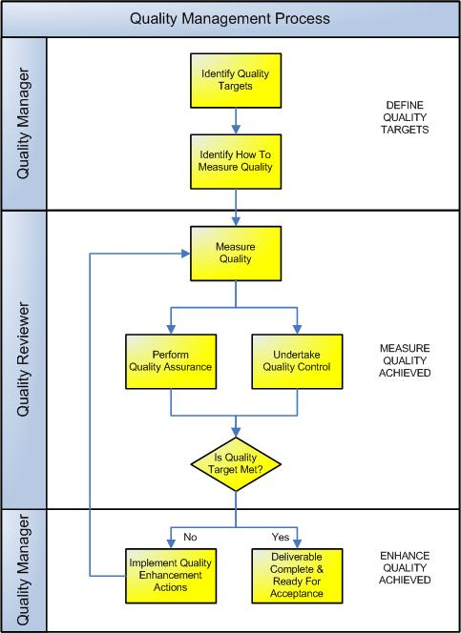

Define Quality Targets
Define the targets and methods of assuring and controlling the level of quality achieved.

    - Identify Quality Targets
List the quality targets defined in the Quality Plan. If these targets have not previously been defined, then complete the following table:

 |  | Quality Targets©
Project  Requirement | Project  Deliverable | Quality Criteria | Quality Standard
New financial management solution with accounts receivable and payables processes | Implementation of Oracle Financials General Ledger (GL), Accounts Payable (AP) and Accounts Receivable (AR) system modules | System functionality  - GL tested & installed  - AP tested & installed  - AR tested & installed  System Performance  - System up-time  - System response-time  - Data transference  completed | System functionality  - GL operational with no errors  - AP operational with no errors  - AR operational with no errors  System Performance  - 99.9% system uptime  - < 1 second response times  - 100% data accuracy

    - Identify How to Measure & Assure Quality
List the methods of assuring and controlling the quality of deliverables and processes within the project (from the Quality Plan).

Measure Quality Achieved
Undertake the assurance and control techniques listed above to assess the actual level of quality of each deliverable and process undertaken within the project.

    - Perform Quality Assurance
Undertake Quality Assurance methods to assure the level of quality of the deliverables and processes. Quality Assurance is defined as “the preventative steps taken to increase the likelihood of delivering a deliverable and achieving the quality targets set”. Quality Assurance techniques are often undertaken at a summarized level of the project by an external project resource. Examples include:

- Referencing historical data to understand areas where quality issues are likely to occur
- Reviewing the requirements of the project to measure deliverables against
- Reiterating the quality standards to be met to clarify the level of quality required
- Recruiting skilled staff to produce the deliverables and undertake the processes
- Undertaking Quality Reviews to provide confidence that the project is on-track
- Performing formal Change Control to minimize the likely number of quality issues. ©

    - Undertake Quality Control
Undertake Quality Control techniques to control the actual level of quality of the deliverables and processes. Quality Control is defined as “the curative steps taken to identify the quality of the actual deliverable delivered and eliminate any variances from the quality targets set”. Quality Control techniques are often undertaken at a detailed level of the project by an internal project resource. Examples include:

- Peer Reviews
- Deliverable Reviews
- Documentation Reviews
- Stage-Gate Reviews
- Process Reviews. ©

Enhance Quality Achieved
After the actual level of quality has been established (through Quality Assurance and Control), compare the level of quality achieved to the quality standards set and implement quality improvement actions as necessary. Finally, report the level of quality achieved and the actions undertaken to the Project Manager for consideration.

    - Undertake Quality Improvement Actions
Assess the results of the Quality Assurance and Control measures to determine the actual quality achieved. Compare the level of quality achieved to the quality standards set and identify any quality deviations. If the level of quality achieved does not meet the standard set, then identify and implement a set of quality improvement actions and begin the measurement of quality again. Continue this process until the quality of the deliverable and process meets the quality standards initially defined.

    - Report Level of Quality Achieved
Regardless of the quality outcome, it is necessary to report the level of quality attained to the Project Manager for consideration. The Project Manager will need to understand the current level of quality of each deliverable and process and record the Quality Improvement Actions within the project plan.

Quality Management Roles

Define the roles and responsibilities for all resources (both internal and external to the project) involved with the assurance and control of quality on the project. For example:

Quality Manager
The Quality Manager ensures that the project produces a set of deliverables which attain a specified level of quality as agreed with the customer. The Quality Manager is formally responsible for:

- Ensuring that Quality Targets are defined for each deliverable
- Implementing Quality Assurance techniques to assure the quality of the deliverables to be produced by the project
- Implementing Quality Control techniques to control the quality of the deliverables actually produced by the project
- Identifying quality deviations and improvement actions for implementation
- Recording the level of quality achieved within the Deliverables Register
- Reporting the quality status to the Project Manager. ©

Quality Reviewer
The Quality Reviewer identifies the actual level of quality associated with the deliverables produced and notifies the Quality Manager of any variations from the quality targets set. A Quality Reviewer may be internal to the project (implementing Quality Control) or external to the project (implementing Quality Assurance). The Quality Reviewer is responsible for:

- Reviewing the quality of deliverables produced and management processes undertaken
- Reporting to the Quality Manager the level of quality attained
- Escalating any quality issues identified between regular reporting periods for immediate action by the Quality Manager. ©

Quality Management Documents

This section lists any other documentation used to assure and control the quality of deliverables and management processes within the project.

Deliverables Register
The ‘Deliverables Register’ is the log / database which records the progress of all deliverables physically constructed. Insert a template for the Deliverables Register here to show how the quality of deliverables will be recorded on this project. (NB Refer to the Method123 ‘Deliverables Register’ for a complete description of this section).

Quality Review Form
The ‘Quality Review Form’ is used to conduct a formal Quality Review of the deliverables and processes within the project. Insert a template for the Quality Review Form here to show how Quality Reviews will be documented within this project (NB Refer to the Method123 ‘Quality Review Form’ for a complete description of this section).

